

**Signals and Systems**

Lab Report #08

# Name:

Taha Saeed

**Registration number:**

FA18-EEE-032

**Submitted to:**

Dr. Ghufran Shafiq

**In-Lab Tasks**

**Task 01: A system is described by the impulse response. Tell if this is a BIBO stable system.**

**Solution:**

syms t;

h = t.^2;

int (abs(h),t,-inf,inf)

t = -10:0.1:10;

x1=ones(size(t));

h = t.^2;

y1=conv(x1,h)*0.1;

plot(-20:0.1:20,y1);

**ans =Inf**

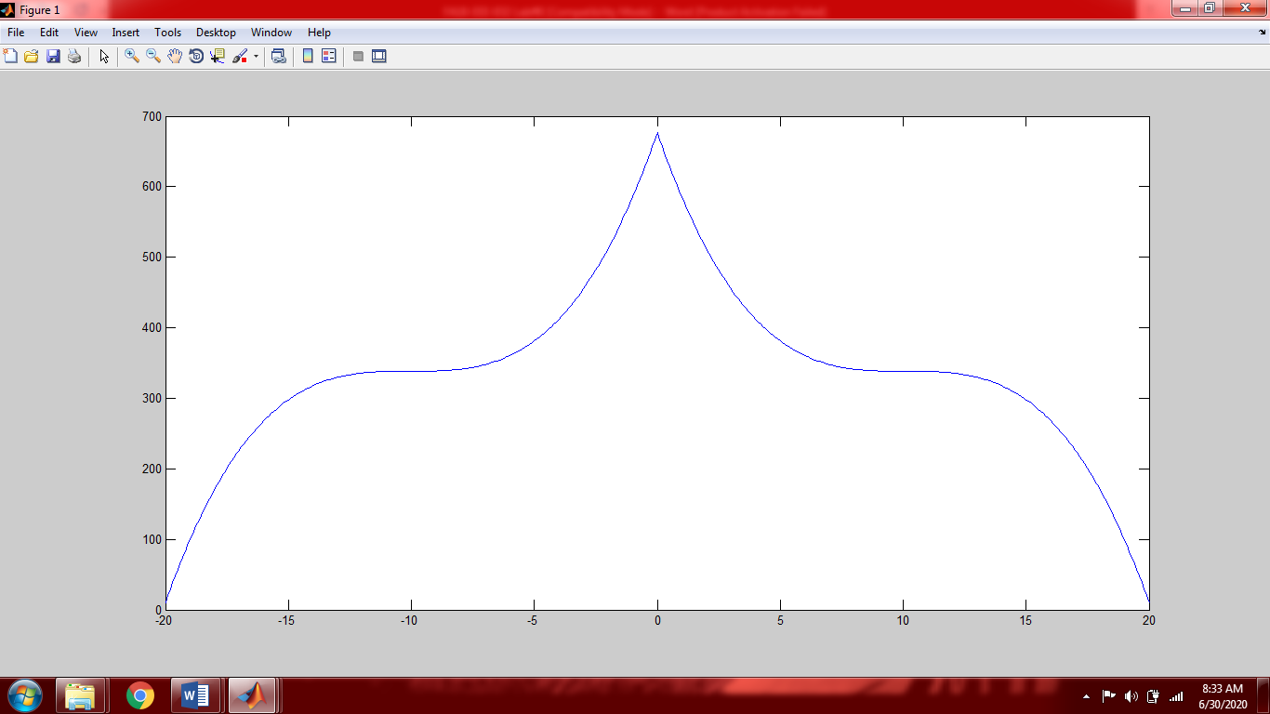

The system is BIBO stable

**Task 02:** Suppose that the impulse response of the subsystems S1 and S2 that are connected as shown in figure below are and . Determine if the overall system is BIBO stable.

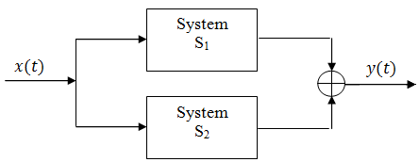

**Solution:**

t=[0:0.01:3];

u=ones(size(t));

subplot(3,1,1);

h1=u.*exp(-3.*t);

plot(t,h1);

title('h1(t)');

subplot(3,1,2)

h2=t.*exp(-2.*t).*u;

plot(t,h2);

title('h2(t)');

subplot(3,1,3);

y=h1+h2;

plot(t,y);

title('y(t)')

syms t

final=exp(-3.*t)+(t.*exp(-2.*t));

int(abs(final),t,0,inf)

**ans =7/12**

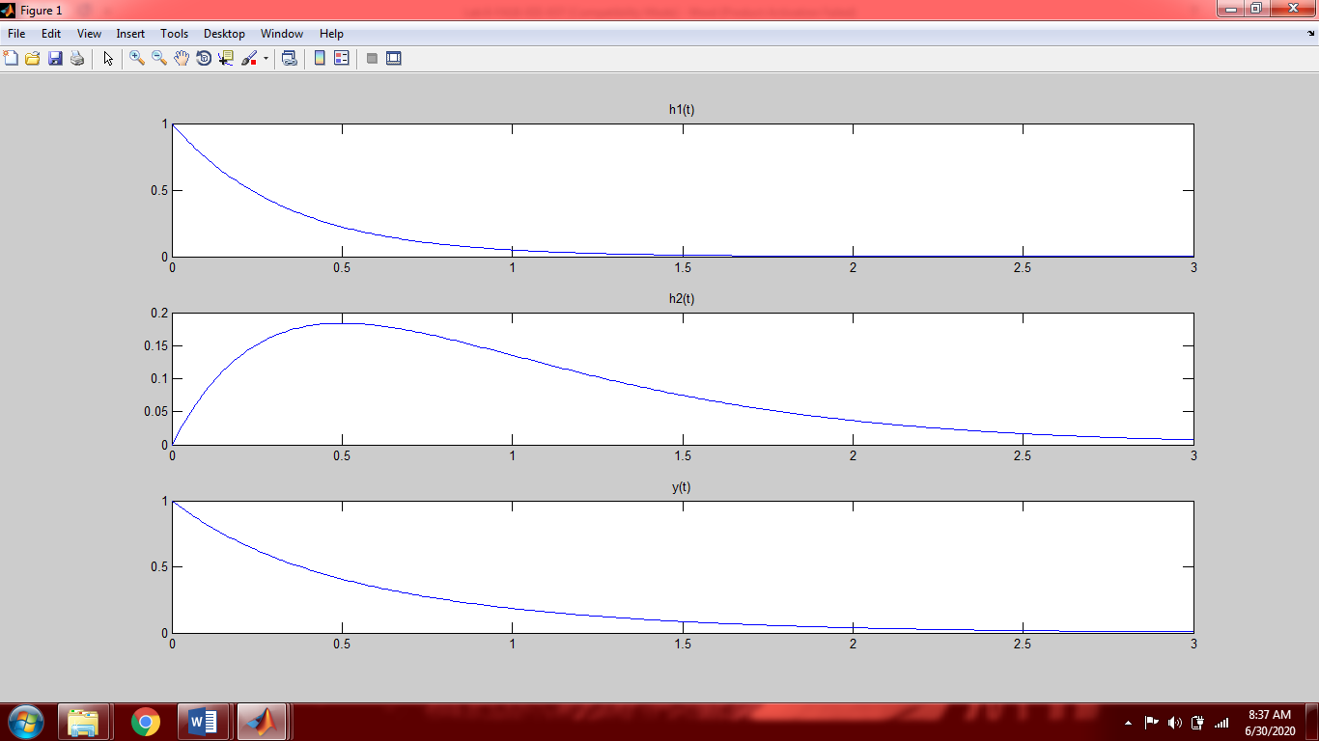

**The system is BIBO stable**

**Task 03:** Suppose that the impulse responses of the sub-systems S1, S2 and S3 that are connected as shown in the figure below are 4 ; 4; and . Compute and plot in the appropriate time interval the impulse response of the overall system and the response of the overall system to the input signal

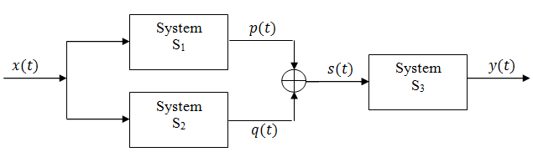

1. Make only one file for this task.
2. Call functions within this m-file which is needed.
3. Compute impulse response of the overall system.
4. Compute the response of the overall system to the given input signal
5. Plot all graphs
6. Determine if the overall system is BIBO stable or not.

**Solution:**

t=[0:0.01:4];

h1=t.*cos(2.*pi.*t);

subplot(3,2,1);

plot(t,h1);

title('h1(t)');

h2=t.*exp(-2.*t);

subplot(3,2,2);

plot(t,h2);

title('h2(t)');

h3=ones(size(t));

S=h1+h2;

subplot(3,2,3);

plot(t,s12);

title('S(t)');

t1=0:0.01:8;

h=conv(S,h3);

subplot(3,2,4);

plot(t1,h);

title('[p(t)+q(t)]*S(t)')

tx=[0:0.01:2];

x=tx.*exp(-2.*tx);

subplot(3,2,5)

plot(tx,x)

title('x(t)')

t2=[0:0.01:10];

h=conv(x,h);

subplot(3,2,6);

plot(t2,h);

title('Overall Response');

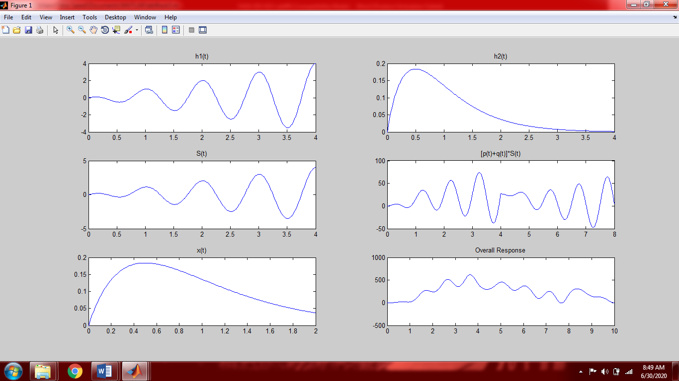

The System is BIBO stable

**Task 04:** Suppose that the impulse responses of the sub-systems S1, S2 and S3 that are connected as shown in the figure below are 2; 2; and 2, respectively. Compute

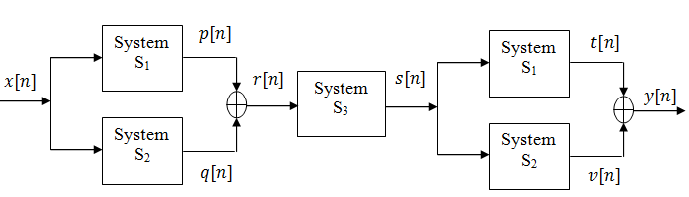

1. Make only one file for this task.
2. Call functions within this m-file which is needed.
3. Compute impulse response of the overall system.
4. Compute the response of the overall system to the given input signal
5. Plot all graphs
6. Determine if the overall system is BIBO stable or not.

**Solution:**

n=[0:1:2];

h1=[2,3,4];

subplot(5,2,1);

stem(n,h1);

title('P[n]');

subplot(5,2,2);

h2=[-1,3,1];

stem(n,h2);

title('q[n]');

subplot(5,2,3);

h3=[1,1,-1];

stem(n,h3);

title('h3[n]');

pq=h1+h2;

subplot(5,2,4);

stem(n,pq);

title('r[n]');

n1=[0:1:4];

rn = conv (pq,h3);

subplot(5,2,5);

stem(n1,rn);

title('S[n]')

n2=[0:1:6];

rx=conv(rn,h1);

subplot(5,2,6);

stem(n2,rx);

title('t[n]');

h11=conv(rn,h2);

subplot(5,2,7);

stem(n2,h11);

title('v[n]');

h=rx+h11;

subplot(5,2,8)

stem(n2,h);

title('h[n]')

xn =[0:1];

x = ones(size(xn));

subplot(5,2,9);

stem(xn,x);

title('x[t]');

y=conv(x,h);

n4=[0:1:7];

subplot(5,2,10)

stem(n4,y);

title('y[n]');

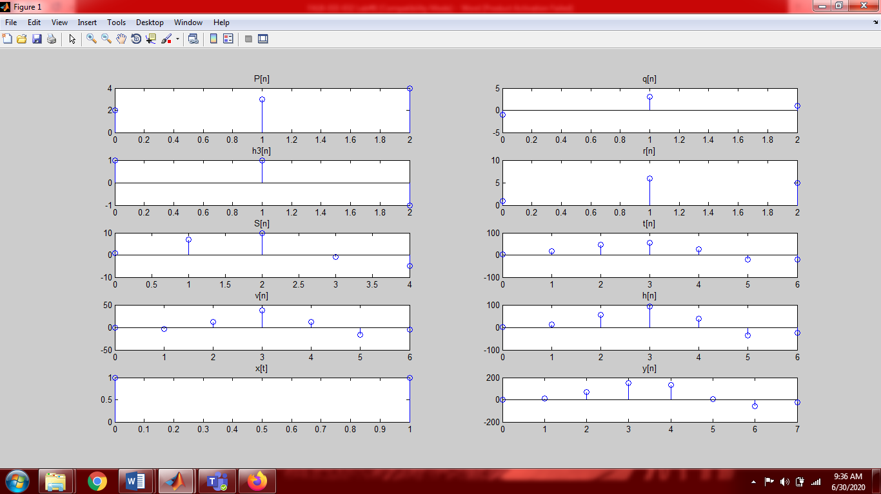

**Post-Lab Tasks**

**Critical Analysis / Conclusion**

In this lab I learnt about the properties of Convolution which are as follow

1. Commutative Property
2. Associative Property
3. Distributive Property
4. Identity Property

A system is bounded-input bounded-output (BIBO) stable if for any bounded applied input; the response of the system is also bounded.